EXP 1:
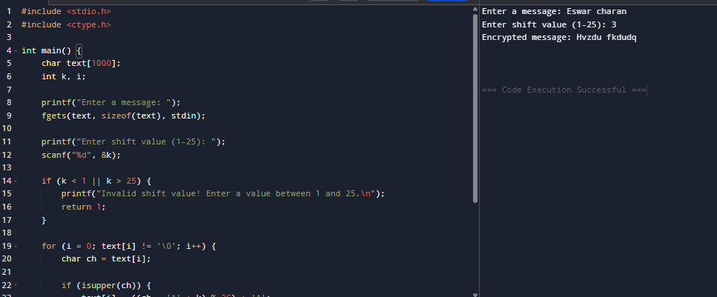

EXP 2:
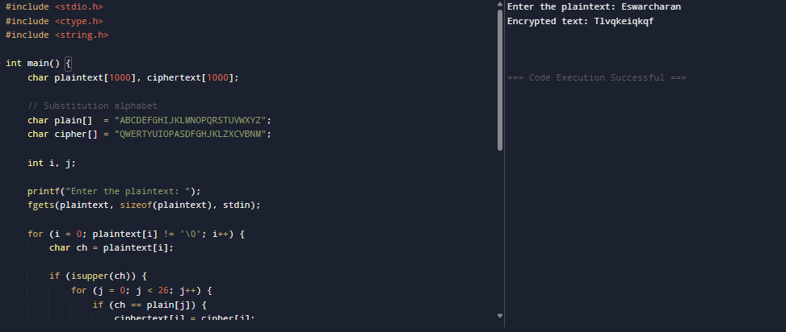
EXP 3:
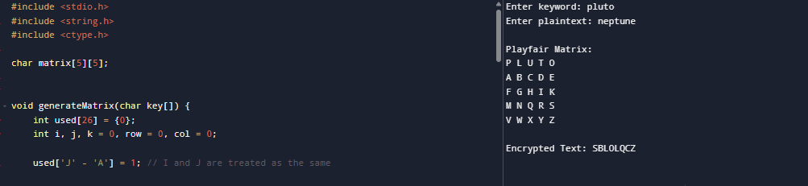

EXP 4:
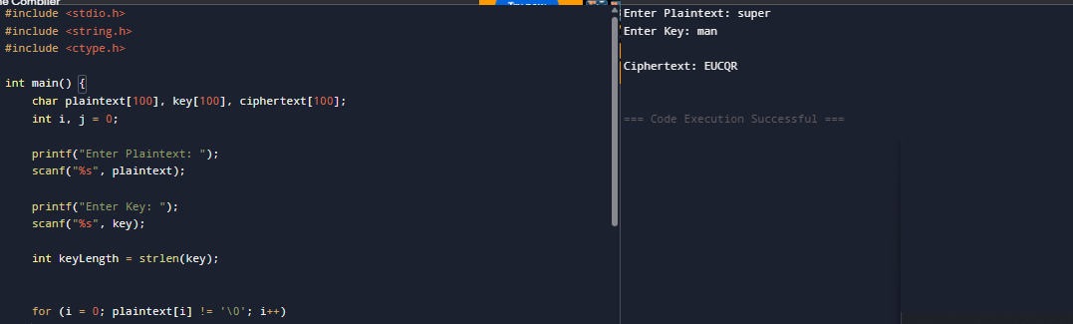
EXP 5:
